Dated 31-05-2024

AWS Backup

Hands on AWS Backup

25.05.2024

Backup

EC2 >>>> AMI or Snapshot

EFS

S3

RDS

etc

Manual or schedule (Automated)

AWS Backup (Regional) >>>>>> Manual or schedule (Automated)

<https://aws.amazon.com/backup/pricing/>

AWS Backup

Centrally manage and automate backups across AWS services

How it works

Create

Build backup plans that define your backup requirements, including backup schedules, backup retention rules and lifecycle rules.

Assign

Assign your AWS resources to backup plans using resource tags or AWS resource IDs. Resources assigned to backup plans are then backed up automatically according to the schedule defined in the plan.

Manage

Use AWS Backup to centrally manage backup configurations, monitor backup activity across AWS services, or restore an AWS resource from a backup.

Define backup plans, schedule backups, automate backup retention management, centrally monitor backup activity, and restore backups.

Step 1 >>> Go to AWS Console and select Storage from Services and Create a Backup Plan

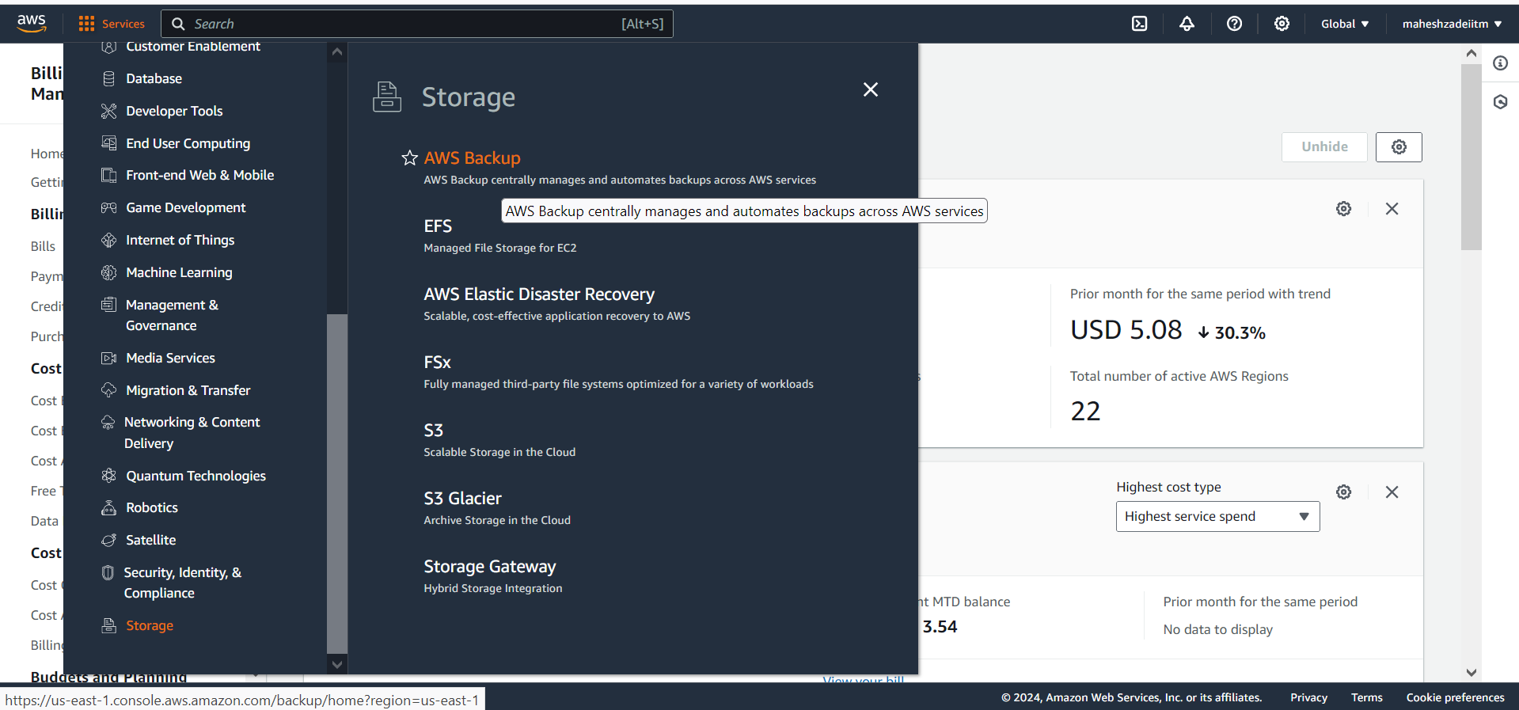

Step 2 >>> Choose your Resources or Assign your Resources

AWS Backup Lab

Lab 1 - On-Demand Backup

Lab 2 - Automated Backup

Lab 3 - Restore

Lab 1 - On-Demand Backup

Pre-req

Backup vault >>>> Create backup vault >>>> Backup vault name >>>> MyVault

Encryption key >>>>> Default

Create

1 - Choose a Region and make sure you have EC2 otherwise create one EC2 with default settings as you know

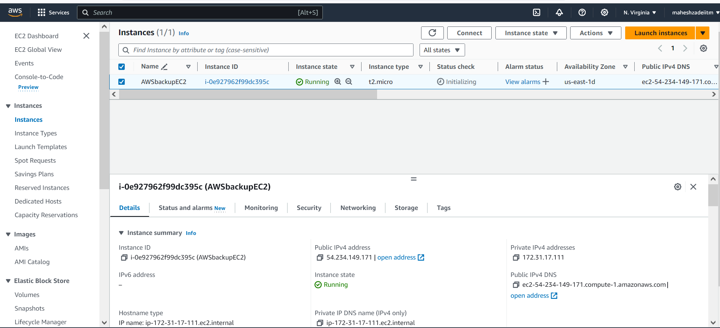

2 - Go to AWS backup then in Protected resources >>> Create on-demand backup

3 - Resource type >>> Ec2

Instance ID >>>> Choose your EC2 that you have created above

Backup window >>>> Create backup now

Total retention period >>>> 1 day

Backup vault >>> Choose the one that you have created above

Click on create backup vault

Backup vault created

Go to previous page of on demand backup.

IAM role >>> Default and give the AWSbackupfull access in IAM Role

Click on Create on-demand backup

Backup in progress it will show and it takes time .

4 - You can monitor under the jobs

Now if you can see "Protected resources" >>>> it is Empty but after Backup completes >>> you can see one Protected resource

Backup is completed

Cleanup your lab >>> Backup vaults >>> Select your resource under Recovery points >>> Actions >>> Delete

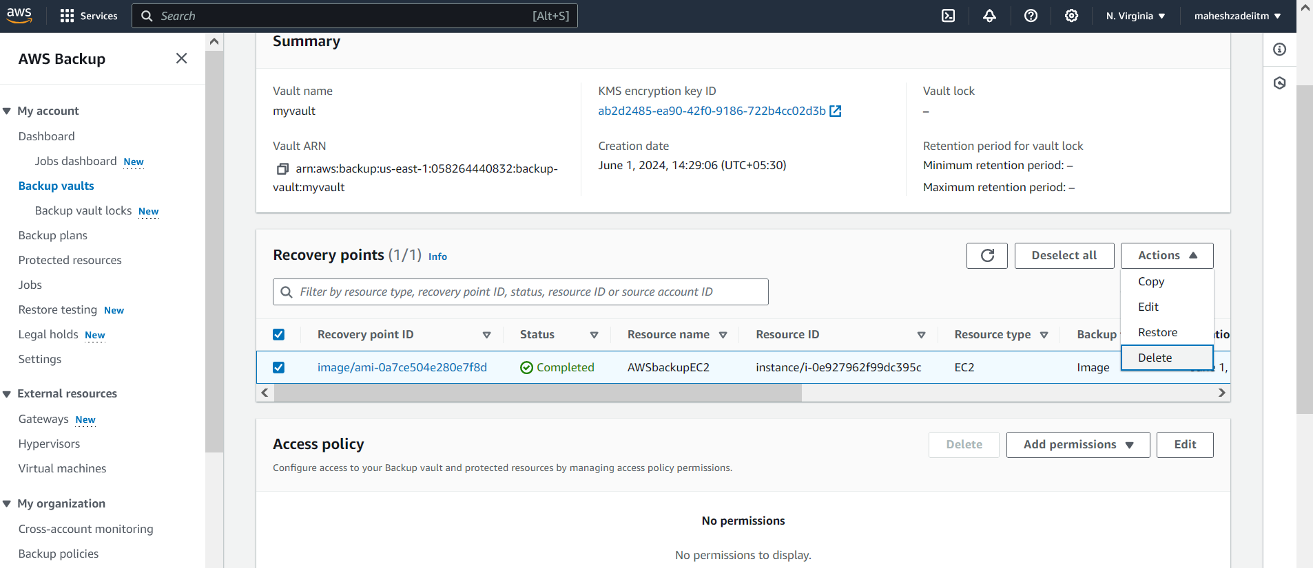

Go back to the protected resources >>> Its empty again.( but in my console 1 is showing

Lab 2 - Automated Backup

1 - Go to Backup plans >>>> Create backup plan >>>>> Build a new plan

Backup plan name >>>>> ec2dailybackup

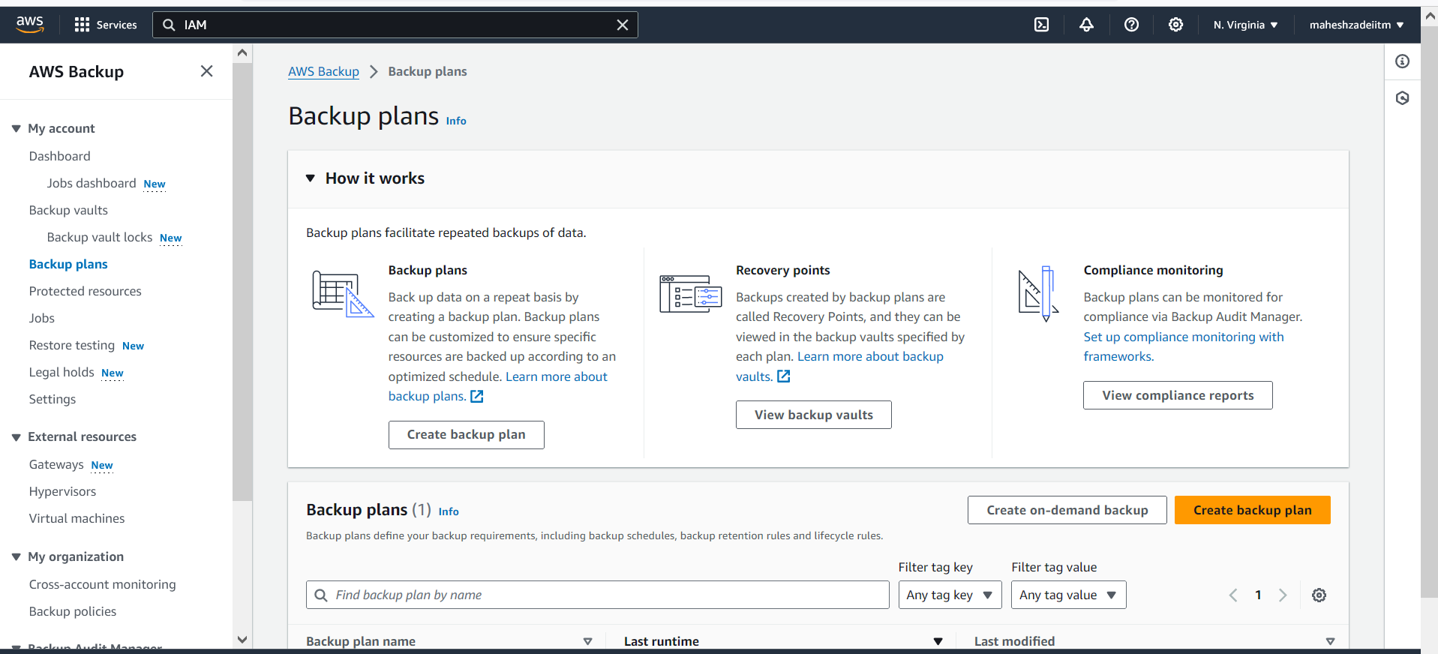

Schedule >>>>> Backup rule name >>> myschedule

Backup vault >>> Choose your Vault

Backup frequency >>> Daily

Backup window >>>> Start time >>> Choose time 3-5 mints ahead for this demo

Start within >>> 1 hour

Complete within >>> 2 hour

Total retention period >>> 1 days

Create a Plan

2 - Assign resources

Resource assignment name >>>> myEC2

IAM role >>> Default Role

Resource selection >>> Include specific resource types

Select specific resource types >>> Ec2

Instance IDs >>> Choose your resource

Click on Assign resources

Keep watching your last runtime at the backup plan

Now go to backup plans>>> Backup rules (1)>> Edit

Also from the Backup jobs

Backup job is crated

Go to Dashboard

Go to jobs under the message category it show success

AWS backup is Successful

Pls check and update hands on .